**How to Change Hostname on Windows Server (2012 R2)**

You can follow the steps below.

1. Right-click the start menu and choose System

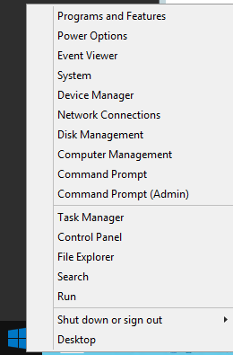

1. Click Advanced system settings

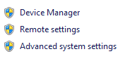

1. In the System Properties, choose the Computer Name tab and click Change

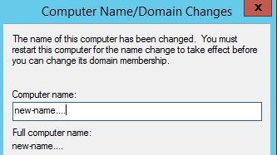

1. Enter Computer name



All done!